**WEB TECHNOLOGY- PROJECT REPORT**

**PROJECT TITLE:** Library Management And book selling Platform.

**PROJECT OBJECTIVE:**

The objective of this project is to develop a **web-based platform** that seamlessly integrates **library management** with a **book selling system**, providing users and administrators with an efficient and user-friendly environment for managing, browsing, and purchasing books. The system aims to:

1. **Display Books Effectively:**
   * Present all available books in the library with details such as title, author, genre, and availability.
   * Organize books under various **themes or categories** for easier browsing.
2. **Book Management and Storage:**
   * Maintain a **digital record of all books** including their stock, themes, and related information.
   * Enable administrators to **add, edit, or remove books** from the platform as needed.
3. **User Interaction and Cart Management:**
   * Allow users to **browse books by category or theme** and **add selected books to a virtual cart** for borrowing or purchase.
   * Provide a clear interface for users to **review and manage their cart items** before checkout.
4. **Admin Verification and Control:**
   * Enable administrators to **verify and approve transactions** or book requests to ensure proper inventory management.
   * Monitor stock levels and user requests, providing a controlled system for library and book selling operations.
5. **Enhanced User Experience:**
   * Ensure smooth navigation, search, and book selection processes.
   * Facilitate easy borrowing or purchase workflow while maintaining library records digitally.

**FRONT END AND BACK END DETAILS:**

**1.Front-End Infrastructure**

The **front-end** is the part of the system that interacts with the user. For your platform, it includes:

**Technologies / Tools:**

* **HTML / CSS / JavaScript:**
  + For designing forms, layouts, and user interface elements.
  + Example: book catalog, cart interface, signup/login pages.
* **AJAX / XMLHttpRequest:**
  + For asynchronous validation and interactions without reloading the page (e.g., validating user input, adding books to cart).
* **Bootstrap (optional):**
  + For responsive design and modern UI components.
* **Browser:**
  + Users interact via standard web browsers like Chrome, Firefox.

**Front-End Components:**

1. **Book Display Page:**
   * Shows available books with details: name, author, theme, availability.
2. **Cart Interface:**
   * Allows users to add/remove books and view selected items before checkout.
3. **User Forms:**
   * Signup/login forms, search functionality, and filtering by themes.
4. **Admin Dashboard (UI):**
   * To verify cart requests, add/update book details, manage themes/categories.

**2.Back-End Infrastructure**

The **back-end** handles data storage, business logic, and validation. For your platform:

**Technologies / Tools:**

* **PHP:**
  + Handles server-side logic like **field validation**, processing user requests, and cart management.
* **JSP / Java Servlets:**
  + Manages registration, admin verification, and more complex workflows if integrated with Java-based logic.
* **MySQL:**
  + Stores all data:
    - Books (name, theme, author, stock)
    - Users (name, email, password, role)
    - Cart and transactions
* **XAMPP:**
  + Apache server for PHP processing and MySQL database management.
* **Tomcat Server (if JSP used):**
  + Serves JSP pages and handles Java-based server logic.

**Back-End Components:**

1. **Database:**
   * Tables for users, books, categories/themes, cart items, and transactions.
2. **Server-side Scripts:**
   * **PHP**: validate input fields, add items to cart, retrieve book lists.
   * **JSP/Servlets**: handle registration, cart verification by admin, checkout processing.
3. **APIs / AJAX Endpoints:**
   * validate.php for field validation
   * JSP endpoints for registration and admin actions

**SCREEN SHOTS:**

**HOME PAGE:**



**SIGN IN:**

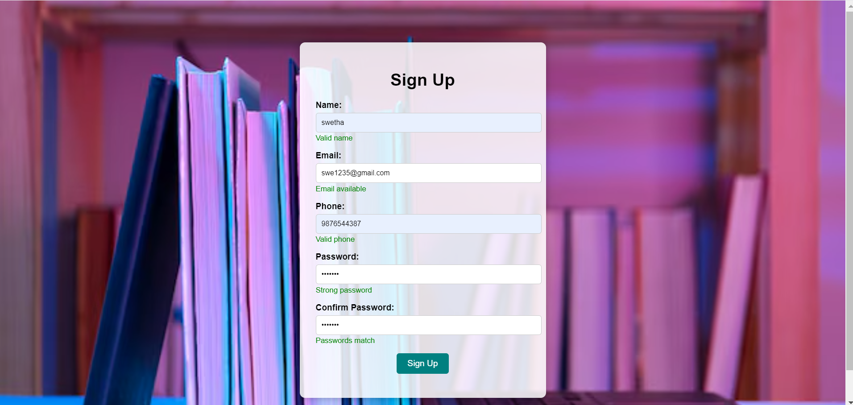

**LOGIN:**



**LIST OF BOOKS:**

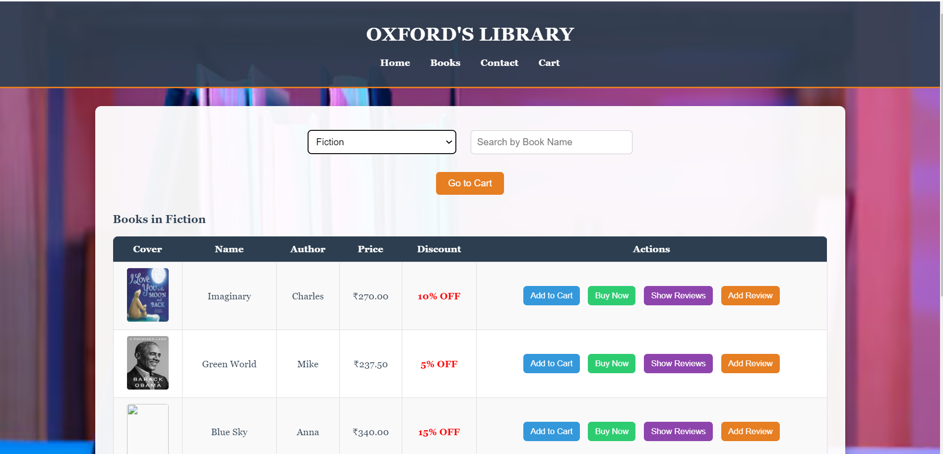

**ADD TO CART:**

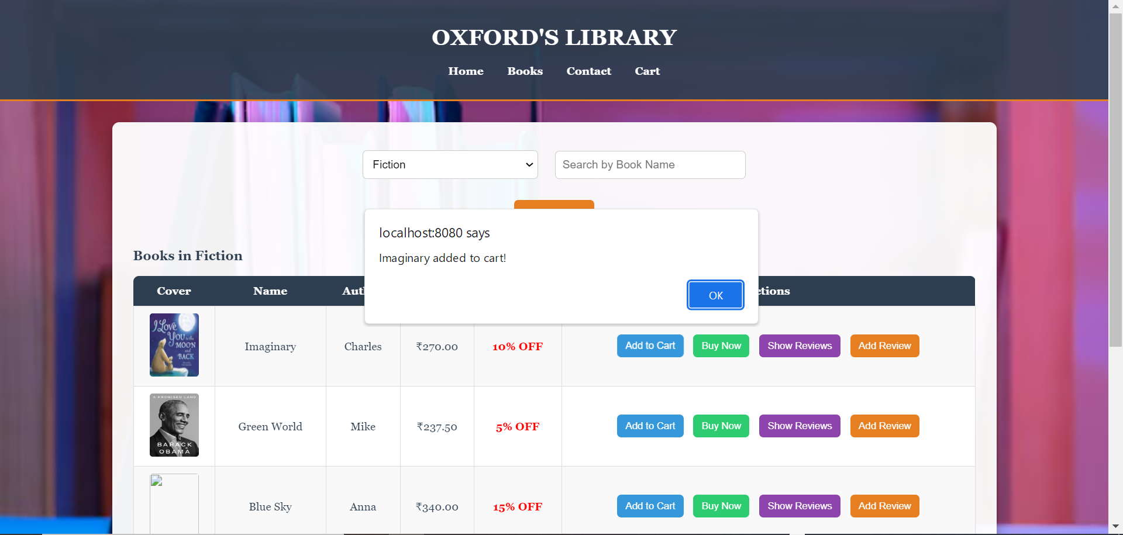

**ADDING REVIEW:**

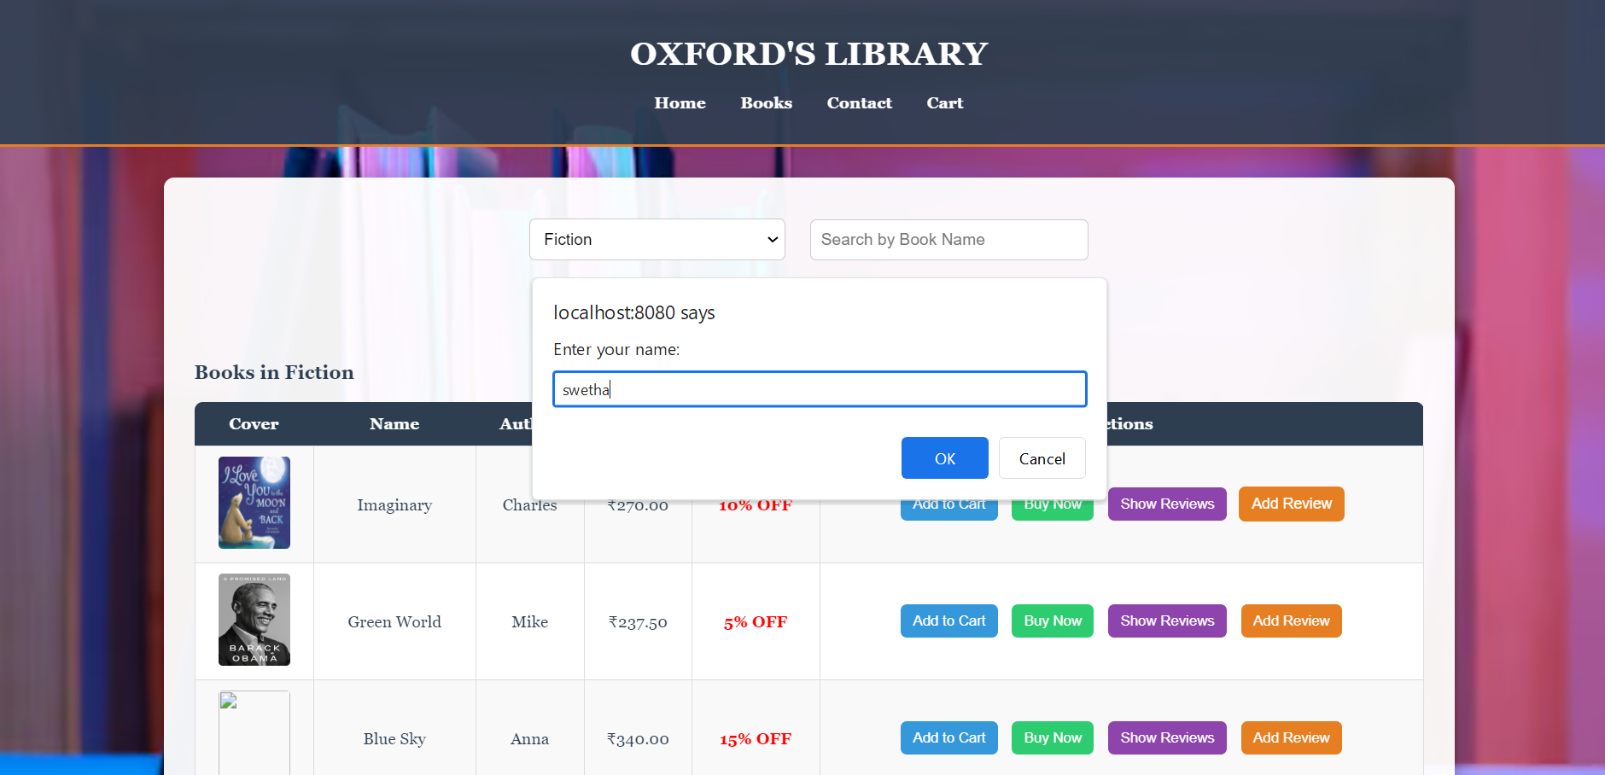

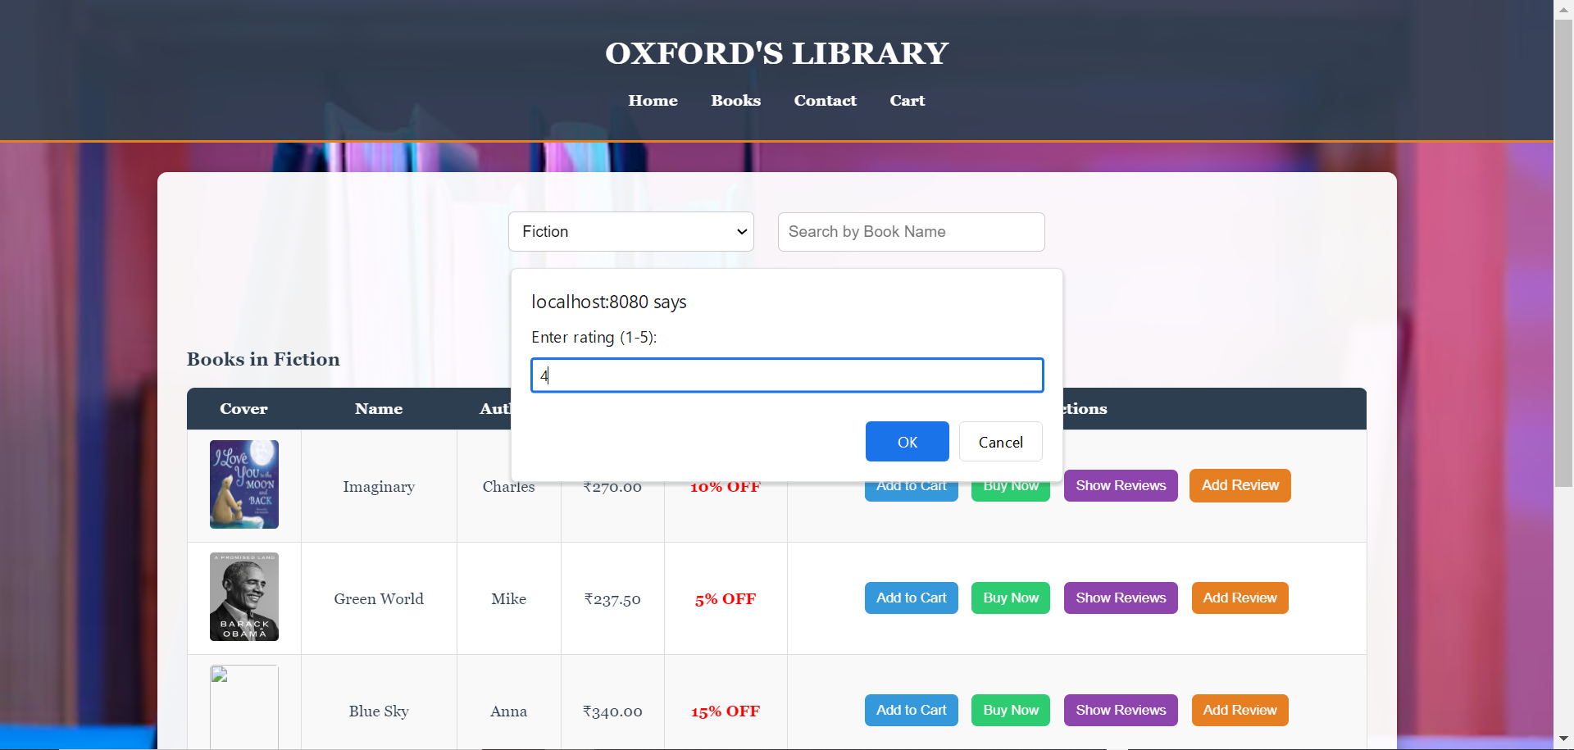

**SHOW REVIEW:**

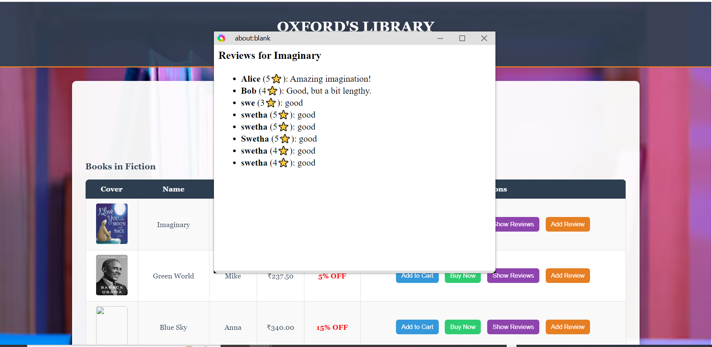

**CART DETAILS:**

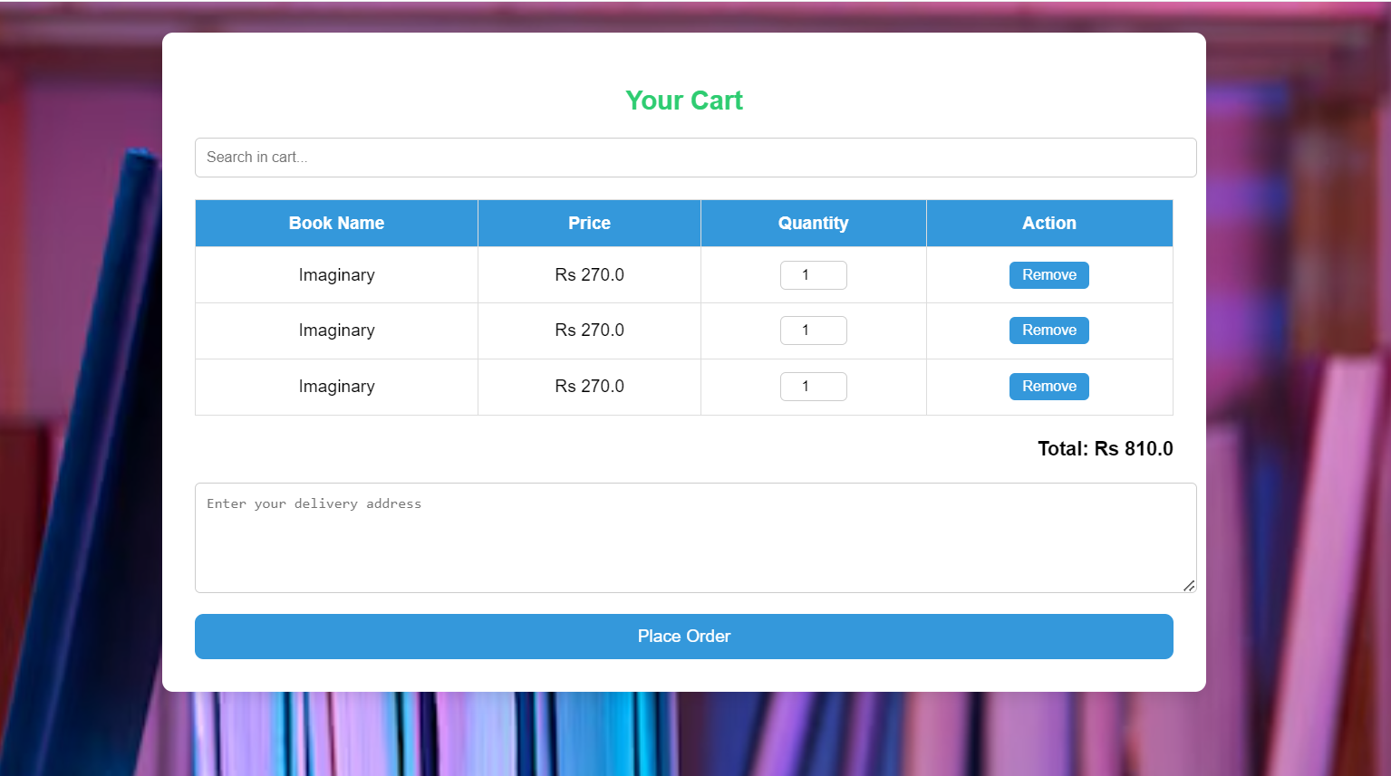

**SEARCH:**

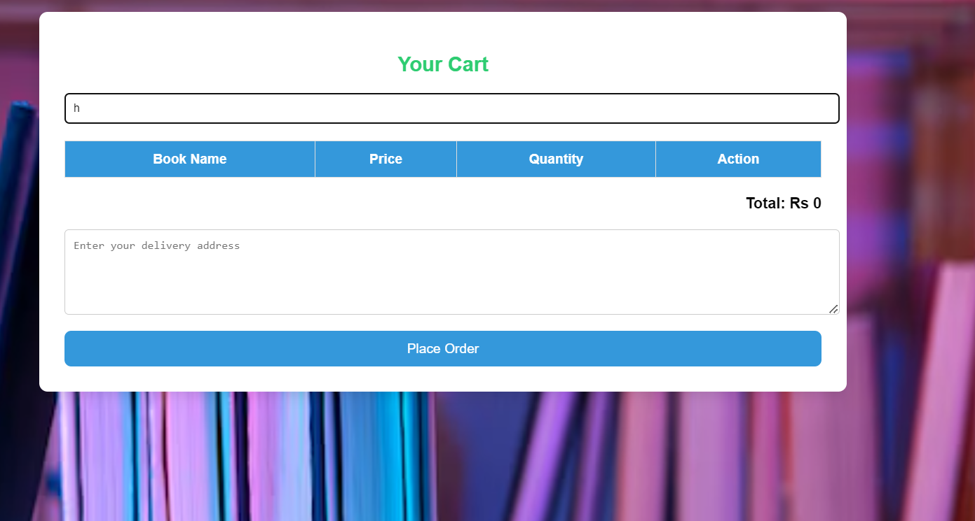

**UPDATE QUANTITY:**

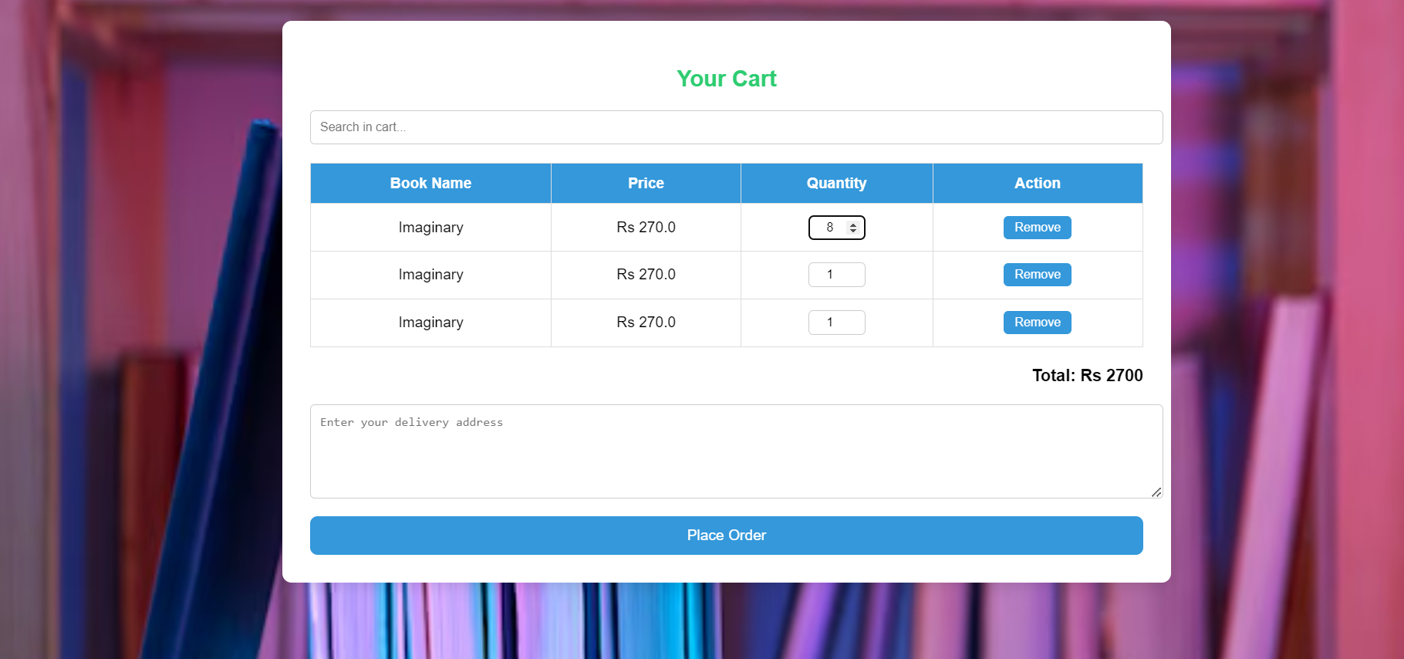

**ORDER PLACED:**

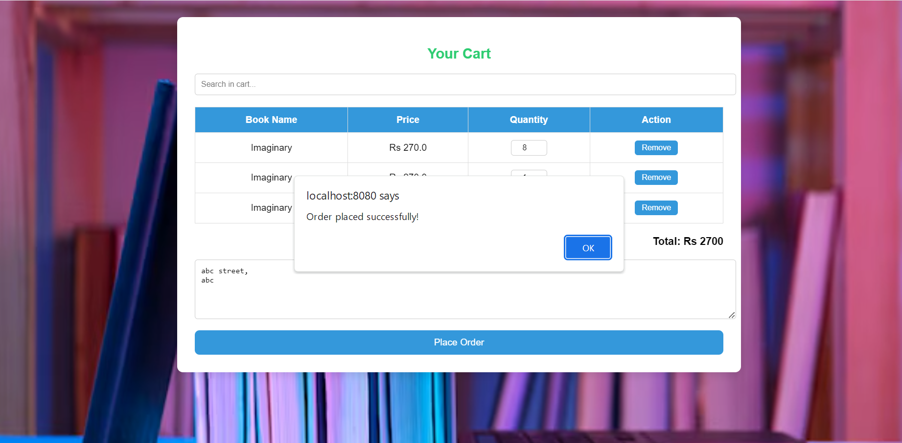

**ORDERS DETAILS:**

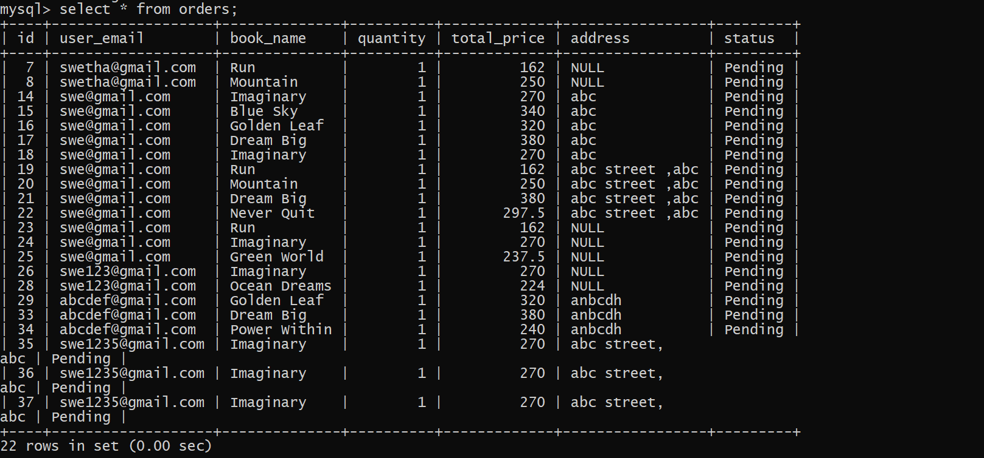

**CONATCT:**

